
SET 2
ANSWER KEY- First term exam (2019-2020)
Subject: ENGLISH  Grade: XI |  | Max. Marks: 80  Time: 3 hrs
Name: |  |  | Section: | Roll No:
General Instructions:
- This question paper consists of 5 printed pages.
- All answers to be written in the answer sheet provided.
I | 1a. do the impossible  2b. ordinary lives  3a. all the necessary equipment to win.  4.b will power  5d. succeed  6a. to understand |  |  |  | 6x1=6
II | i. We can be wise by using our brain |  |  |  | 6x1=6
 | ii. Everyone shares all that the greatest of men have had.
 | iii. A person can become great and victorious by using his skill and strengthening his will power.
 | iv. The greatest handicap that a person faces in life is his “own self”
 | v. handicap
 | vi. take control over self
2a  b. | Note Making Title —1 Mark;  Abbreviations and Key —1Mark;  Content—3 Marks (3-5 headings & 0-3 sub-headings with proper indentation and notes  Content must be divided into headings and sub-headings.  Complete sentences not to be accepted as notes  Numbering of headings and sub-headings may be indicated in different ways as long as a consistent pattern is followed  Summary- Content- 2 Marks; Expression—1 Mark
3. | Notice --- Format-1 Mark; Content—2 Marks; Expression –1 Mark  OR  Poster--------Content—2 Marks; Expression—2 Marks  (Should be eye-catching, pithy and appropriate language to be used.
4. | Formal Letter  Format(Sender‘s address, Address of addressee, date, subject, salutation, body and complimentary close)—2 Marks  Content or Body of the letter---2marks ; Expression----2marks
5. | Formal Letter  Format(Sender‘s address, Address of addressee, date, subject, salutation, body  and complimentary close)—2 Marks  Content or Body of the letter---2marks ; Expression----2marks
6. | Article----Format (heading, name)—1Mark;  Content—4 Marks; Expression –3
7. | Error Correction  Has ------------had  hold-------------held  Or---------------and  confess-------- confessed  his------------- their  to----------- for |  |  |  | 1/2x6=3
8.  9 | a) Good friends make our life extremely happy.  b) However, these days it is not easy to find good friends / These days however, it is not easy to find good friends/ However, it is not easy to find good friends these days.  c) Is the newspaper being read by her every morning?  ANY TWO  - These lines are from the poem “The Laburnum Top”, written by Ted Hughes.  - The chirruping of the goldfinch is called eerie because just as it mysteriously appeared suddenly out of nowhere and made the dead tree come alive, it flies way as mysteriously leaving behind an eerie silence.  c) The goldfinch’s arrival had transformed the tree into a bedlam of chirruping. The tree was full of noisy trills and appeared to be swaying with the notes going high and low. |  |  |  | 1x3=3  1x2=2
10. | Value Points:-  a) Sparrows-came to mourn the death of the grandmother. They came in thousands – sat silently—did not touch bread crumbs—offered their silent homage and flew away silently  b) Observation made by Assyrian farmer John Byro-after looking into the mouth of the horse-matched tooth for tooth-would have claimed it as his own horse if he had not known their parentage-believed that the boys were honest and could not steal as they belonged to the Garoghlanian tribe which was famous for their honesty-the resemblance was so striking that he called it the twin of his horse.  c) The narrator wanted to forget the address-no.46, Marconi Street-she had remembered the address as the place was emotionally linked to her memory as all her mother‘s belongings were kept in there.-her mother was no more present in this world-when she visited the address she found all her mother‘s things were kept in a distasteful manner—the things had lost their emotional value as the objects which are linked in our memory immediately lose their value when those objects are seen after sometime in strange surroundings—the things had lost their charm—if taken back the things would again seem strange in her new small rented room-moreover without her mother, the objects have lost their emotional attachment.  d) The boy king changed his own name from Tutankhaten to Tutankhamun means ‘living image of Amun’ because Amun was a major God in ancient Egypt. But the previous King had made his people worship the Sun God Aten. He had smashed all the images of Amun. When Tut became the king, he restored the old ways.  e) The laburnum tree gets an identity because of the nest built on its top. During the month of September, the tree is left with a few yellowing leaves only. It is visited regularly by the mother goldfinch bird. She comes to feed her young ones. The silence is broken for a while but restored again.  f) the death of the mother delivers a stunning blow and silences the poet forever. the poet realized that death is true and real and the silence of death silences everyone. thus, the poet comes to terms with the muting silence of death. |  |  |  | 2x5=10
11a. | 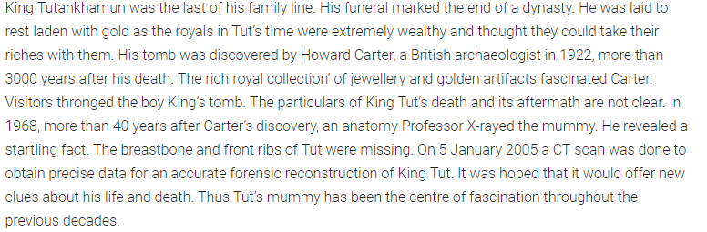 |  |  |  | 1x6=6
b. | 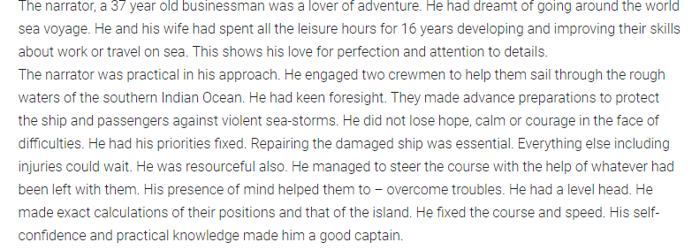
12a. | 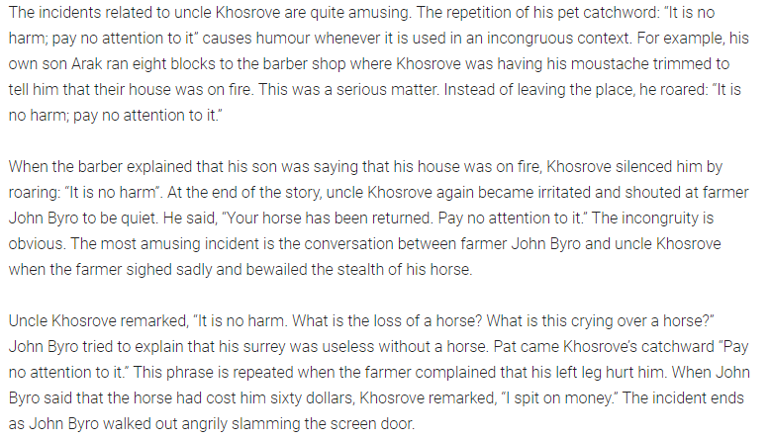 |  |  |  | 6
b. | 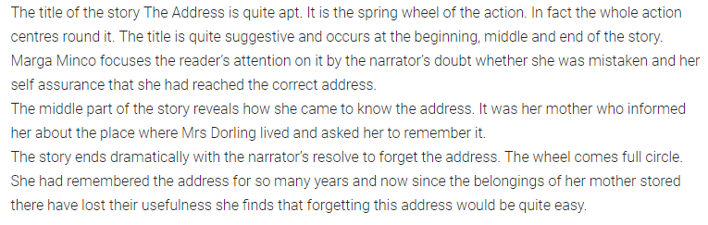
13a | 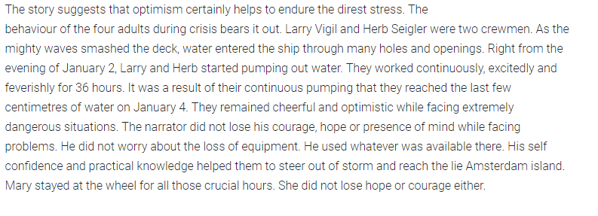 |  |  |  | 6
b. | 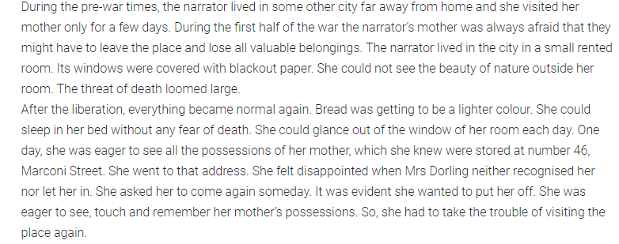 |  |  |  | 6

